1 CSA-1557 CLOUD COMPUTING LAB PRACTICAL

2.Create a simple cloud software application for Property Buying & Rental process (In Chennai city) using any Cloud Service Provider to demonstrate SaaS include the necessary fields such as Buy, Rent, commercial, Rental Agreement , Rental Agreement, Area, place, Range, property value etc

# STEP-1:

Login into zoho.com and create an account.Then go to zoho creator and create a new application starting with a new form.Add or insert the required fields.

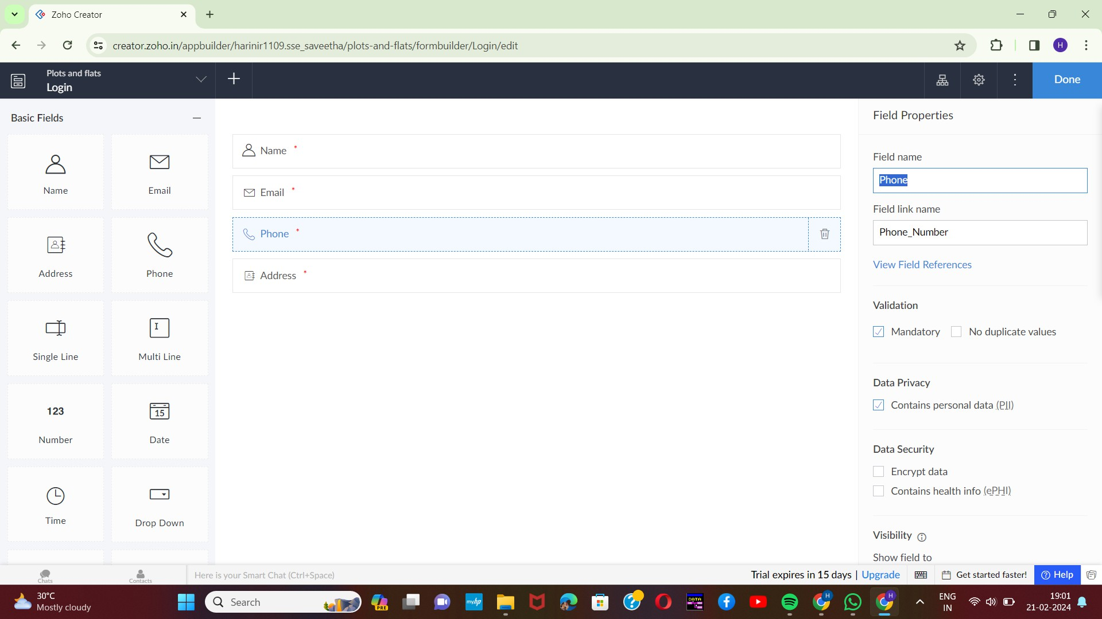

2

# STEP-2:

Execute or run the model and get the required login form in live.

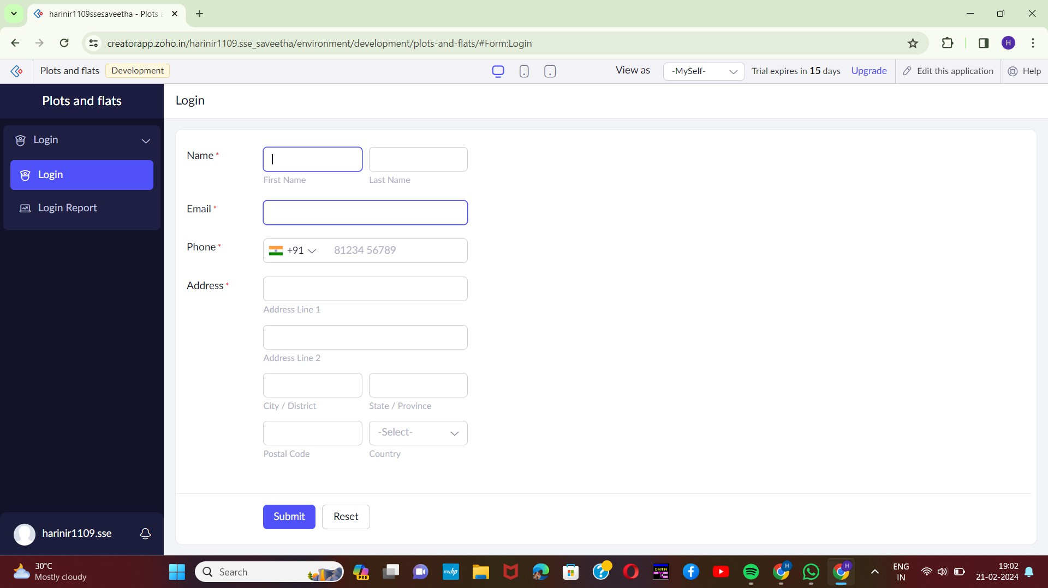

# STEP-3:

Next step is to add another form which consists of appointment booking with the

fields.

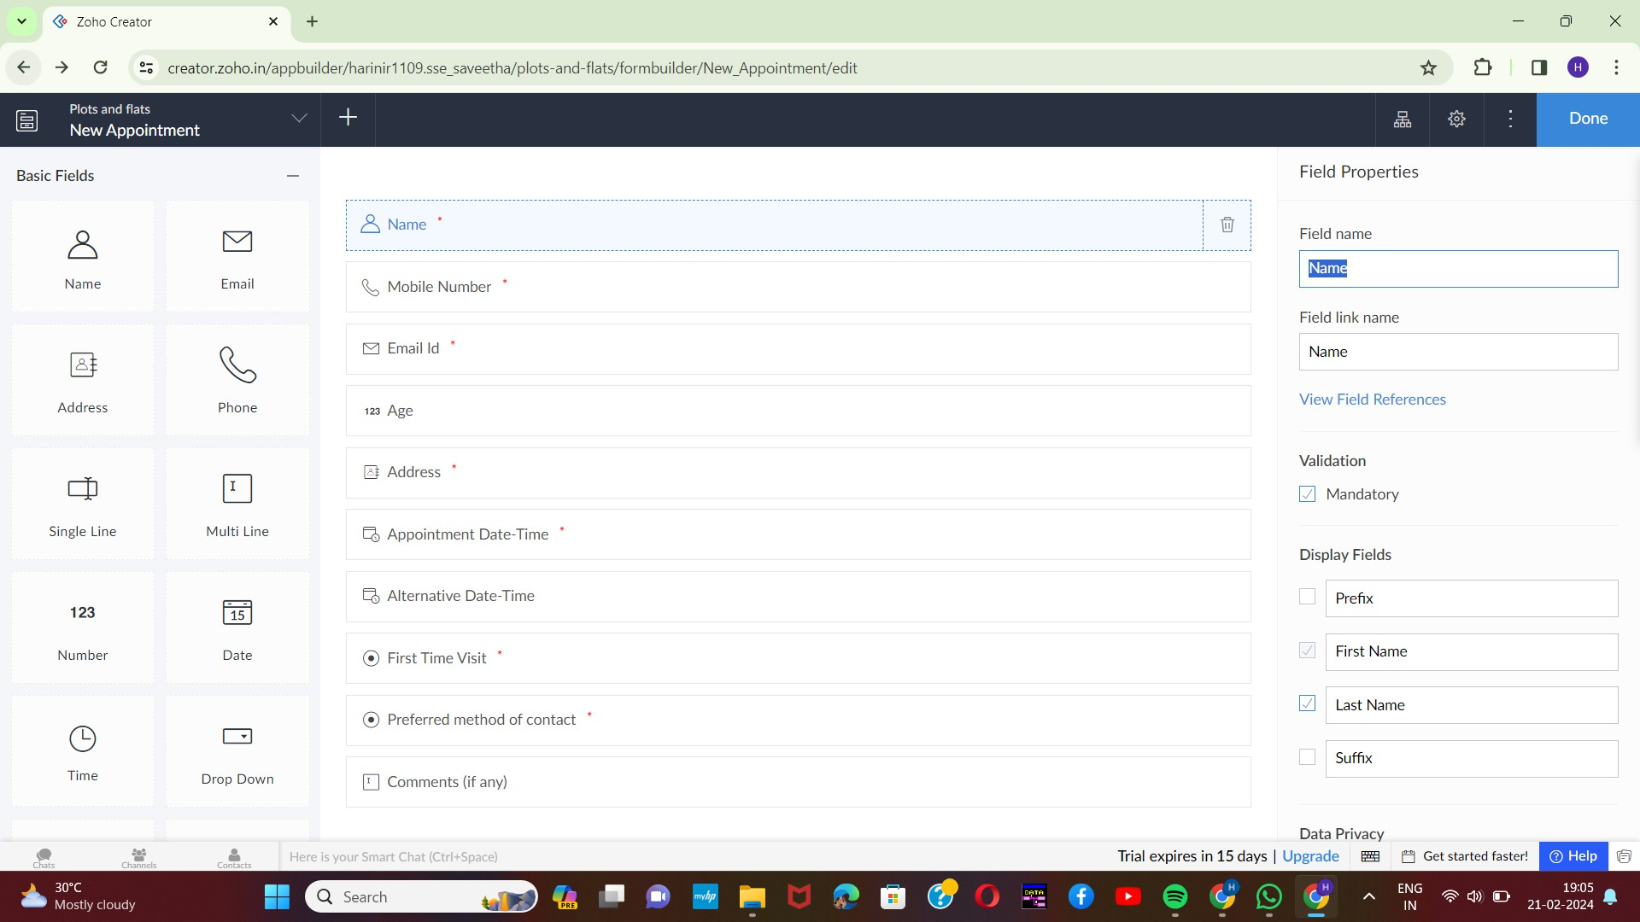

3

# STEP-4:

Execute or run the model and get the required booking form live.

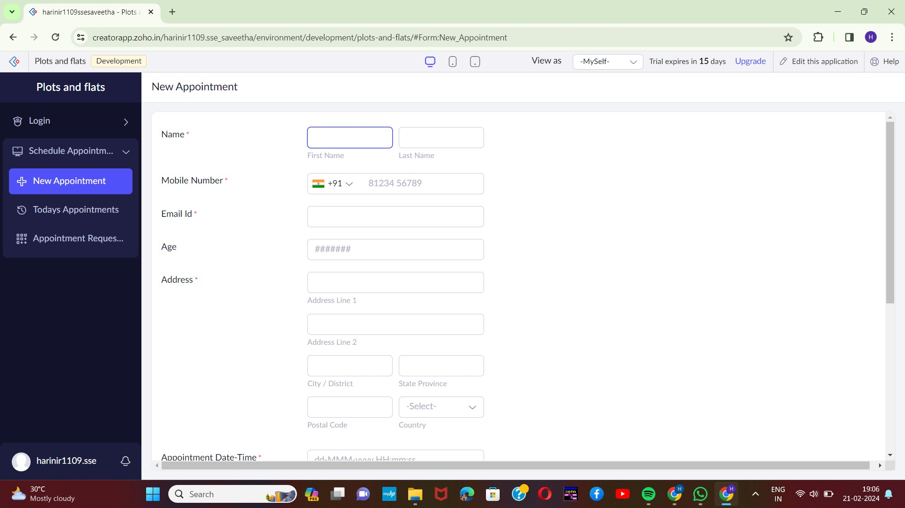

4

# STEP-5:

fields.

Next step is to add another form which consists of selection of property with the

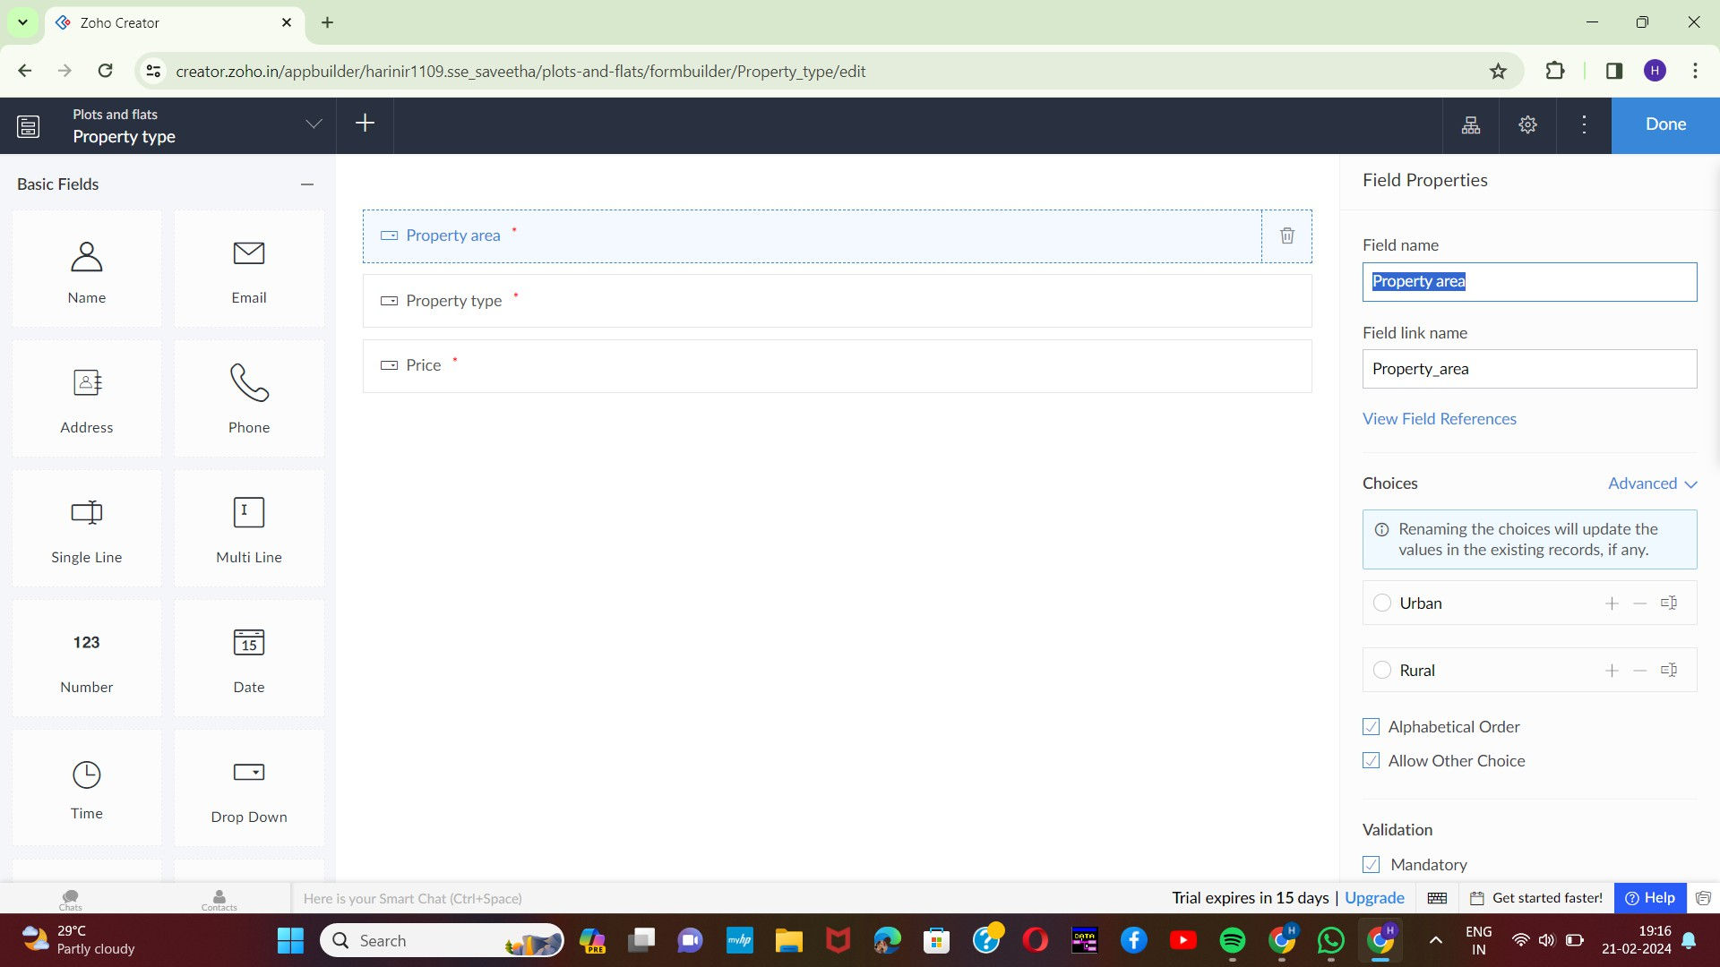

5

# STEP-6:

Execute or run the model and get the required property selected from live.

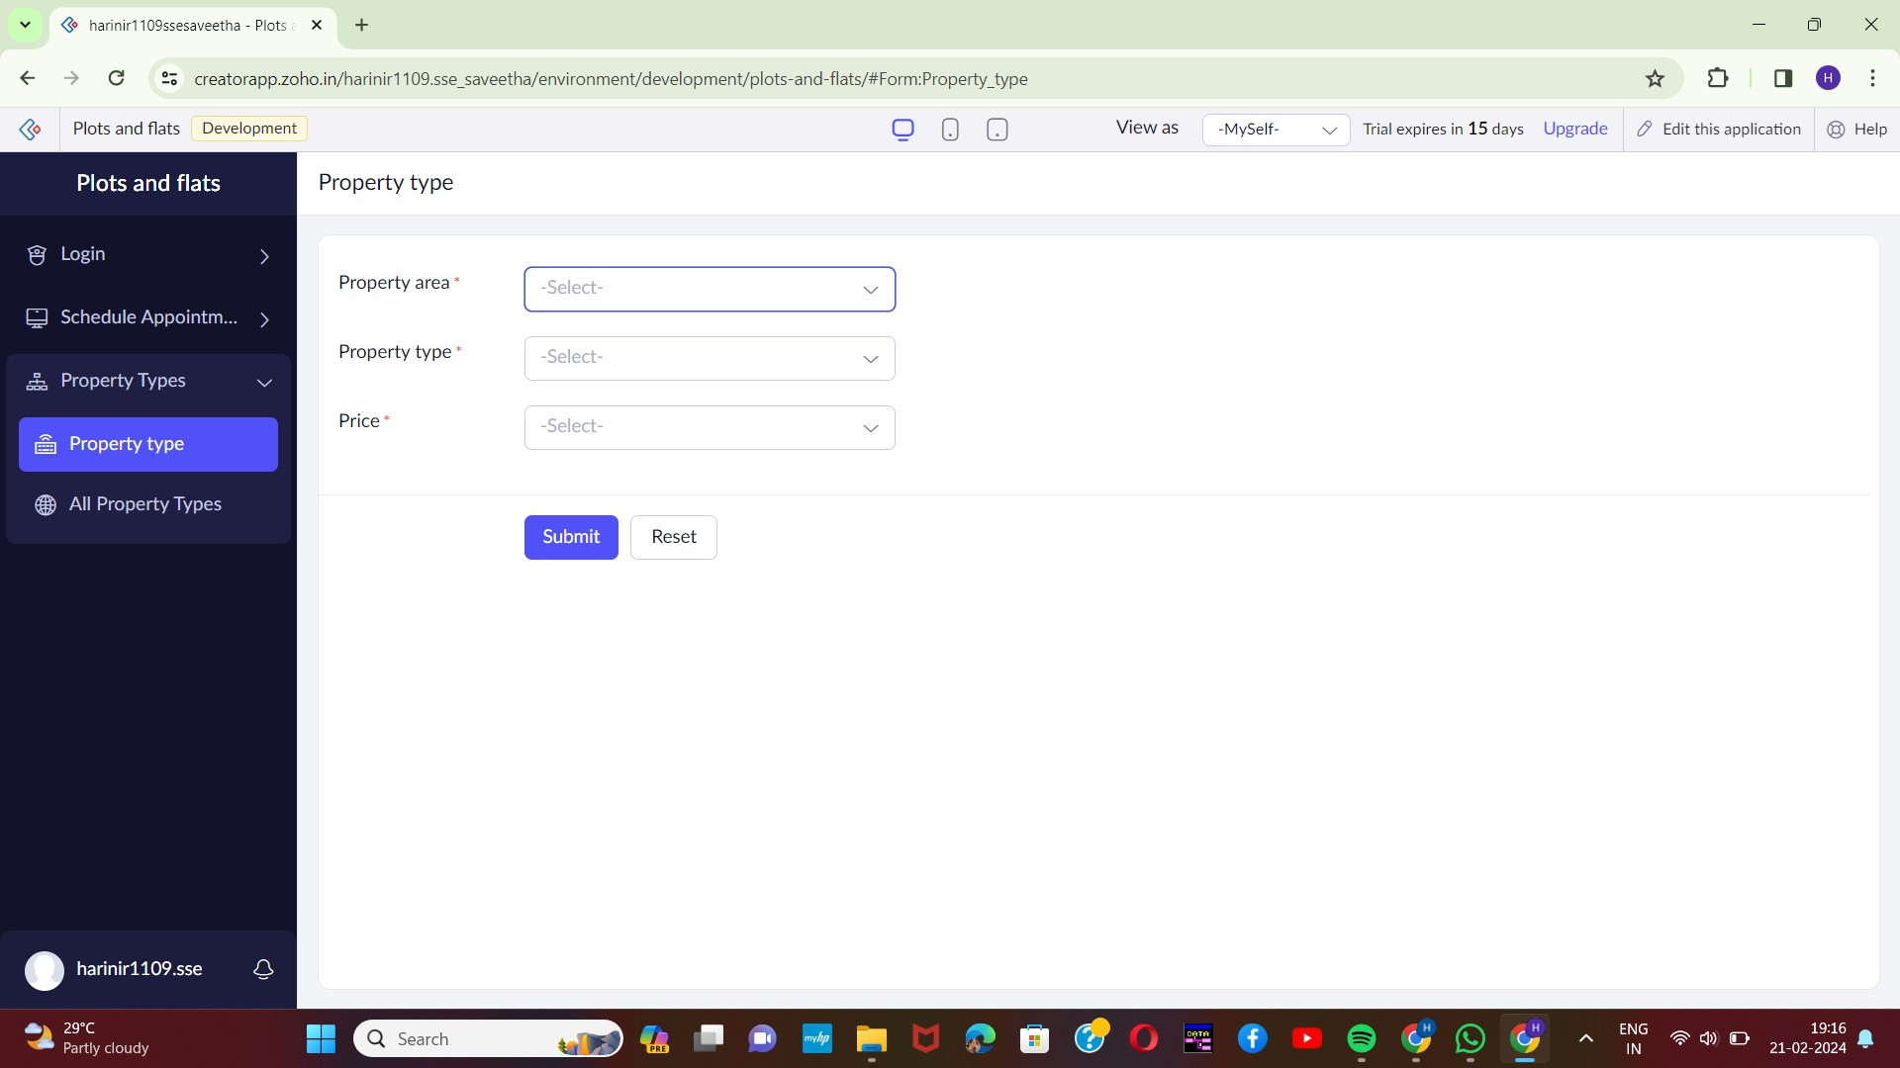

6

# STEP-7:

Next step is to add another form which consists of contact details.

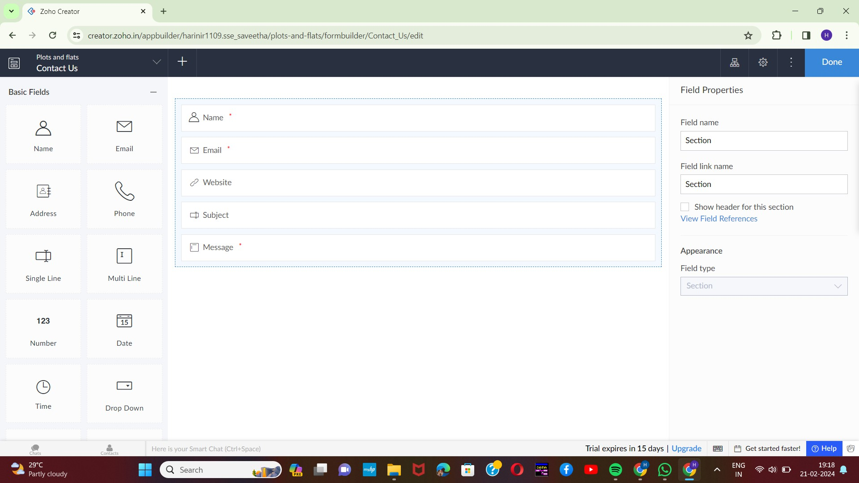

# STEP-8:

The last step is to run and execute the contact details form and end the program.

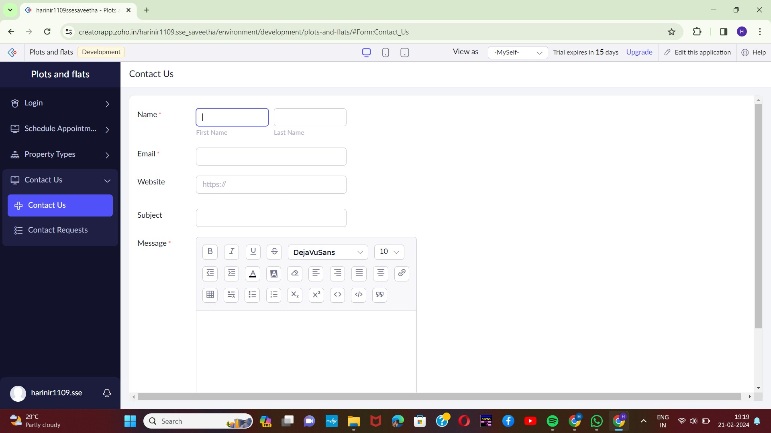

7